Day 4: The Rider’s View

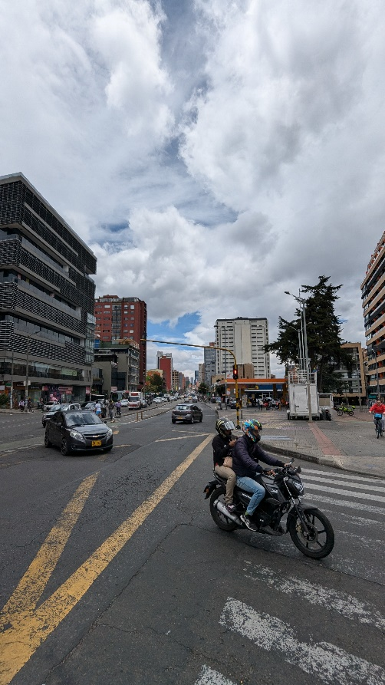

*This street scene was captured by Giancarlo, but perhaps he left out an historic detail. What nearby monument can the rider see from their vantage point?*

*The monument is to a person, what is their name?*

On 19 December 2024, the page does not show the image anymore. Therefore, I retrieved the image from a snapshot of 10 December 2024 on the Wayback Machine. From Zooming into this picture, I can only make out the license plate of the car, I’m not able to get any direct clues on the location. So, I start by doing a Google Reverse Image search. Two results are an exact match, which I decide to ignore due to them being possibly related to writing up this challenge. One of the other first hits is from a website from Tony Andersen, which seems to include the same white building that is seen in the picture of this challenge. Looking closer, I am also able to match the other buildings (see below). Clicking on this page, I find out that the location is Bogota. Now I need to figure out the exact location, so I can find out what the perspective of the rider is. When reverse image searching the picture I found, I get another hit for this location, with a more zoomed out perspective (see below). This page at archdaily.com says the street is called Carrera Septima. Let’s look up this street in Google Maps. This actually seems to be a pretty long street. Let’s see if we can find a gas station along this street, nearby some kind of park with a few trees. Eventually I am able to find the correct location in Google Street View (see below). Turning my perspective, I see a statue of a man in the park. Exiting Google Street View, this monument is marked as being:

**Julio Flórez**.

